Q1.Write a program containing a possible exception. Use a try block to throw it
and a catch block to handle it properly.
SOLUTION:-
PROGRAM:-
#include <iostream>
using namespace std;
int main()
{
int x = -1;
try
{
if (x < 0)
{
cout <<"Throw Exception"<<endl;
throw x;
}
}
catch (int x )
{
cout << "Exception Caught"<<endl;
}
return 0;
}
OUTPUT:-

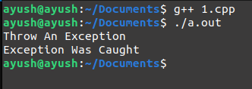

Q2.Write a program that illustrates the application of multiple catch statements.
SOLUTION:-
PROGRAM:-
#include<iostream>
using namespace std;
int main()
{
cout << "Testing multiple catches"<<endl;
int x;
cin>>x;
try
{
if (x > 0)
throw x;
else
throw 'x';
}
catch (int x)
{
cout << "Integer Caught "<<endl;
}
catch (char x)
{
cout << "Character is Caught " <<endl;
}
}
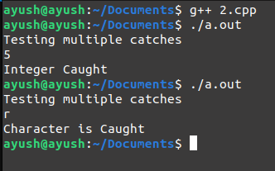
OUTPUT:-

Q3.Write a program which uses catch(...) handler.
SOLUTION:-
PROGRAM:-
#include <iostream>
using namespace std;
int main()
{
try
{
throw 'x';
}
catch (int a)
{
cout << "Caught Integer "<<endl;
}
catch (...)
{
cout << "Default Exception"<<endl;
}
return 0;
}
OUTPUT:-

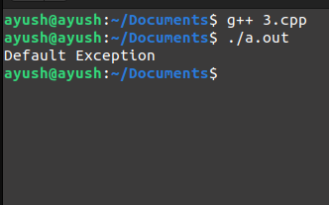

Q4.Write a program to demonstrate the concept of rethrowing an exception.
SOLUTION:-
PROGRAM:-
#include<iostream>
using namespace std;
void add(int i,int j)
{
try
{
if(i==1)
{
throw i;
}
else
cout<<"Addition result is: "<<i+j<<endl;
}
catch(int i)
{
cout<<"Exception caught inside add()"<<endl;
throw;
}
};
int main()
{
try
{
add(10,5);
add(1,49);
}
catch(int k)
{
cout<<"Exception caught inside main()"<<endl;
}
return 0;
}
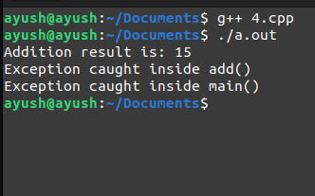
OUTPUT:-

Q5.Write a program with the following:
(a) A function to read two double type numbers from keyboard
(b) A function to calculate the division of these two numbers
(c) A try block to throw an exception when a wrong type of data is keyed in
(d) A try block to detect and throw an exception if the condition "divide-by-
zero" occurs
(e) Appropriate catch block to handle the exceptions thrown.
SOLUTION:-

PROGRAM:-
#include <iostream>
using namespace std;
double a, b;
void accept()
{
cout << "Enter any two Numbers\n";
try
{
cin >> a;
if (cin.fail())
throw(a);
cin >> b;
if (cin.fail())
throw(b);
}
catch (...)
{
cout << "Incompatible Datatype for value\n";
exit(0);
}
}
void calculate()
{
try
{
if (b == 0)
throw b;
cout << a / b;
}
catch (double y)
{
cout << "Divide By Zero";
}
}
int main()
{
accept();
calculate();
return 0;
}

OUTPUT:-
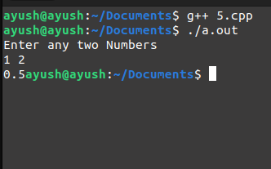

Q6.Write a main program that calls a deeply nested function containing an
exception. Incorporate necessary exception handling mechanism.
SOLUTION:-
PROGRAM:-
#include <iostream>
using namespace std;
int main()
{
try
{
try
{
throw 20;
}
catch (int n)
{
cout << "Handle Partially \n";
throw;
}
}
catch (int n)
{
cout << "Handle remaining \n";
}
return 0;
}

OUTPUT:-
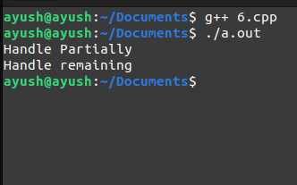

Q7.Write a program for user defined exception for
(a) Checking Temperature (if temp reaches certain threshold throw exception)
(b) Validate age (if age is greater than some value)
SOLUTION:-
PROGRAM:-
#include <iostream>
using namespace std;
int main()
{
double temp;
cout << "Enter Temperature\n";
cin >> temp;
try
{
if (temp > 100)
throw(temp);
else
cout << "You can go Outside \n";
}
catch (const double a)
{
cout << "Too Hot Outside \n";
}
int age;
cout << "Enter Age:\n";
cin >> age;
try
{
if (age < 18)
throw age;
else
{
cout << "You can vote\n";
}
}
catch (const int a)
{
cout << "Underaged can't vote\n";
}
return 0;
}
OUTPUT:
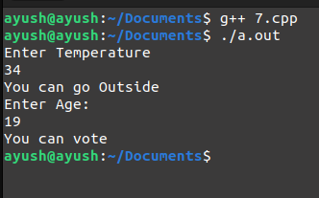

Q8.Create a base class called shape. Use this class to store two double type values
that could be used to compute the area of figures. Derive two specific classes
called triangle and rectangle from the base shape. Add to the base class, a
member function get_data() to initialize base class data members and another
member function display_area() to compute and display the area of figures.Make display_area() as a virtual function and redefine this function in the
derived classes to suit their requirements.
Using these three classes, design a program that will accept dimensions of a
triangle or a rectangle interactively, and display the area. Remember the two
values given as input will be treated as lengths of two sides in the case of
rectangles, and as base and height in the case of triangles, and used as follows:
Area of rectangle = x * y
Area of triangle = 1/2 * x * y
SOLUTION:-
PROGRAM:-
#include<iostream>
#include<iomanip>
using namespace std;
class shape
{
public:
double x,y;
public:
void get_data()
{
cin>>x>>y;
}
double get_x(){return x;}
double get_y(){return y;}
virtual void display_area(){}
};
class triangle:public shape
{
public:
void display_area()
{
double a;
a=(x*y)/2;
cout<<" Area of triangle = "<<a<<endl;
}
};
class rectangle:public shape
{
public:
void display_area()
{
double a;
a=x*y;
cout<<" Area of rectangle = "<<a<<endl;
}
};
int main()
{
shape *s[2];
triangle t;
s[0]=&t;
rectangle r;
s[1]=&r;
cout<<" Enter the value of x & y for triangle: ";
s[0]->get_data();
cout<<" Enter the value of x & y for rectangle: ";
s[1]->get_data();
s[0]->display_area();
s[1]->display_area();
return 0;
}

OUTPUT:-

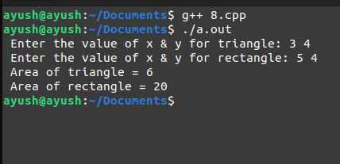

Q9.Extend the above program to display the area of circles. This requires addition
of a new derived class 'circle' that computes the area of a circle. Remember,
for a circle we need only one value, its radius, but the get_data() function in
the base class requires two values to be passed.
SOLUTION:-
PROGRAM:-
#include <iostream>
#include <iomanip>
#define pi 3.1416
using namespace std;
class shape
{
public:
double x, y;
public:
void get_data(double a, double b)
{
x = a;
y = b;
}
double get_x() { return x; }
double get_y() { return y; }
virtual void display_area() {}
};
class triangle : public shape
{
public:
void display_area()
{
double a;
a = (x * y) / 2;
cout << " Area of triangle = " << a << endl;
}
};
class rectangle : public shape
{
public:
void display_area()
{
double a;
a = x * y;
cout << " Area of rectangle = " << a << endl;
}
};
class circle : public shape
{
public:
void display_area()
{
double a;
a = pi * x * x;
cout << " Area of circle = " << a << endl;
}
};
int main(){
shape *s[3];
triangle t;
s[0] = &t;
rectangle r;
s[1] = &r;
circle c;
s[2] = &c;
double x, y;
cout << " Enter the value of x & y for triangle: ";
cin >> x >> y;
s[0]->get_data(x, y);
cout << " Enter the value of x & y for rectangle: ";
cin >> x >> y;
s[1]->get_data(x, y);
cout << " Enter the radius of circle : ";
double rd;
cin >> rd;
s[2]->get_data(rd, 0);
cout << endl<< endl;
s[0]->display_area();
s[1]->display_area();
s[2]->display_area();
return 0;
}
OUTPUT:-
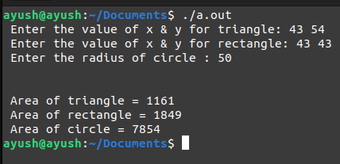
Q10.Run the above program with the following modifications:
(a) Remove the definition of display area() from one of the derived classes.
(b) In addition to the above change, declare the display_area() as virtual in the
base class shape.
SOLUTION:-
PROGRAM:-
#include <iostream>
#include <iomanip>
#define pi 3.1416
using namespace std;
class shape
{
public:
double x, y;
public:
void get_data(double a, double b)
{
x = a;
y = b;
}
double get_x() { return x; }
double get_y() { return y; }
virtual void display_area() {}
};
class triangle : public shape
{
public:
void display_area()
{
double a;
a = (x * y) / 2;
cout << " Area of triangle = " << a << endl;
}
};
class rectangle : public shape
{
public:
void display_area()
{
double a;
a = x * y;
cout << " Area of rectangle = " << a << endl;
}
};
class circle : public shape
{
public:
void display_area()
{
double a;
a = pi * x * x;
cout << " Area of circle = " << a << endl;
}
};
int main()
{
shape *s[3];
triangle t;
s[0] = &t;
rectangle r;
s[1] = &r;
circle c;
s[2] = &c;
double x, y;
cout << " Enter the value of x & y for triangle: ";
cin >> x >> y;
s[0]->get_data(x, y);
cout << " Enter the value of x & y for rectangle: ";
cin >> x >> y;
s[1]->get_data(x, y);
cout << " Enter the radius of circle : ";
double rd;
cin >> rd;
s[2]->get_data(rd, 0);
cout << endl<< endl;
s[0]->display_area();
s[1]->display_area();
s[2]->display_area();
return 0;
}

OUTPUT:-
